HOLIDAY WORKSHEET-2

CLASS: VII SUBJECT: MATHEMATICS

- ACTIVITY:
- Make 2d shapes foldable using chart and paper.
- Make modal of tiny house and calculate area and perimeter.

- LOGICAL THINKING:
- Put the numbers 1, 2, 3, 4, 5, 6 and 7 in the circles so that each straight line of three numbers adds up to the same total.

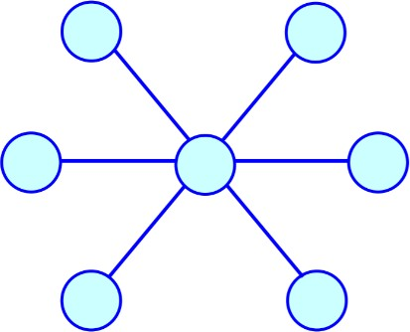

- How many am I?
  - I am a three digit number.
  - I am an odd number.
  - I am divisible by 5.
  - Each of my digits is different.
  - My digits add up to 8.
  - The tens digit is smaller than the hundreds digit.
  - I am less than 300.
  - I have only one even digit.

- GRAPHICAL REPRESENTATION:
- The below graph represent the number of dogs to cats in a shelter:

dogs | 1 | 2 | 10 | 12
cats | 3 | 6 | 30 | 36

Graph the data from the ratio table above:

- ARTHIMETIC SKILL:

- A tank has three taps.
The first tap takes 2 hours to fill the pool, the second tap takes 3hours, and the last one takes 6 hours. How long will it take to fill the tank using all three taps at once?

- Write the natural numbers from 2 to 14. What fraction of them are prime numbers?

